Probability

One coin tossed

Sample space = {H, T} # equally likely event

Probability of head = ½

Probability of Tail = ½

One die is thrown

Sample space = {1,2,3,4,5,6}

Possibility: P(1) = $\frac{1}{6}$

Probability: P 1 or 6) = 2/6 =1/3

Probability: P(2 and 6) = 0 / 6 # Mutually Exclusive event one die cannot give two outcome 2 or 6 at a time it give only one outcome

Probability: P(even) = 3/6 = 1/2

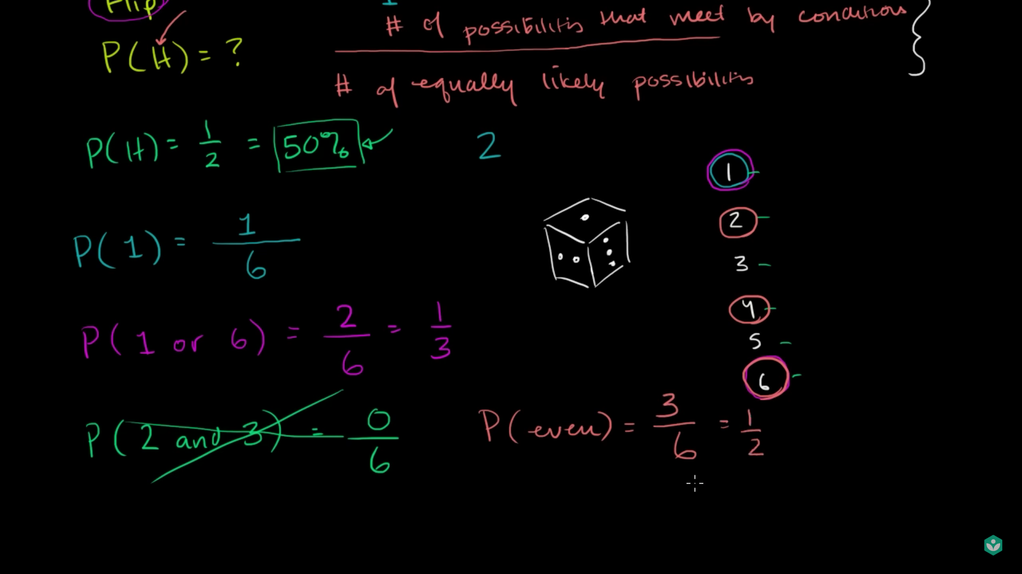

Lecture Two

A Deck of cards

Have 4 suits of heart , spades , club(leaf), diamond

Have no of cards

A, 2,3,4,5,6,7,8,9,10,Jack, King, Queen

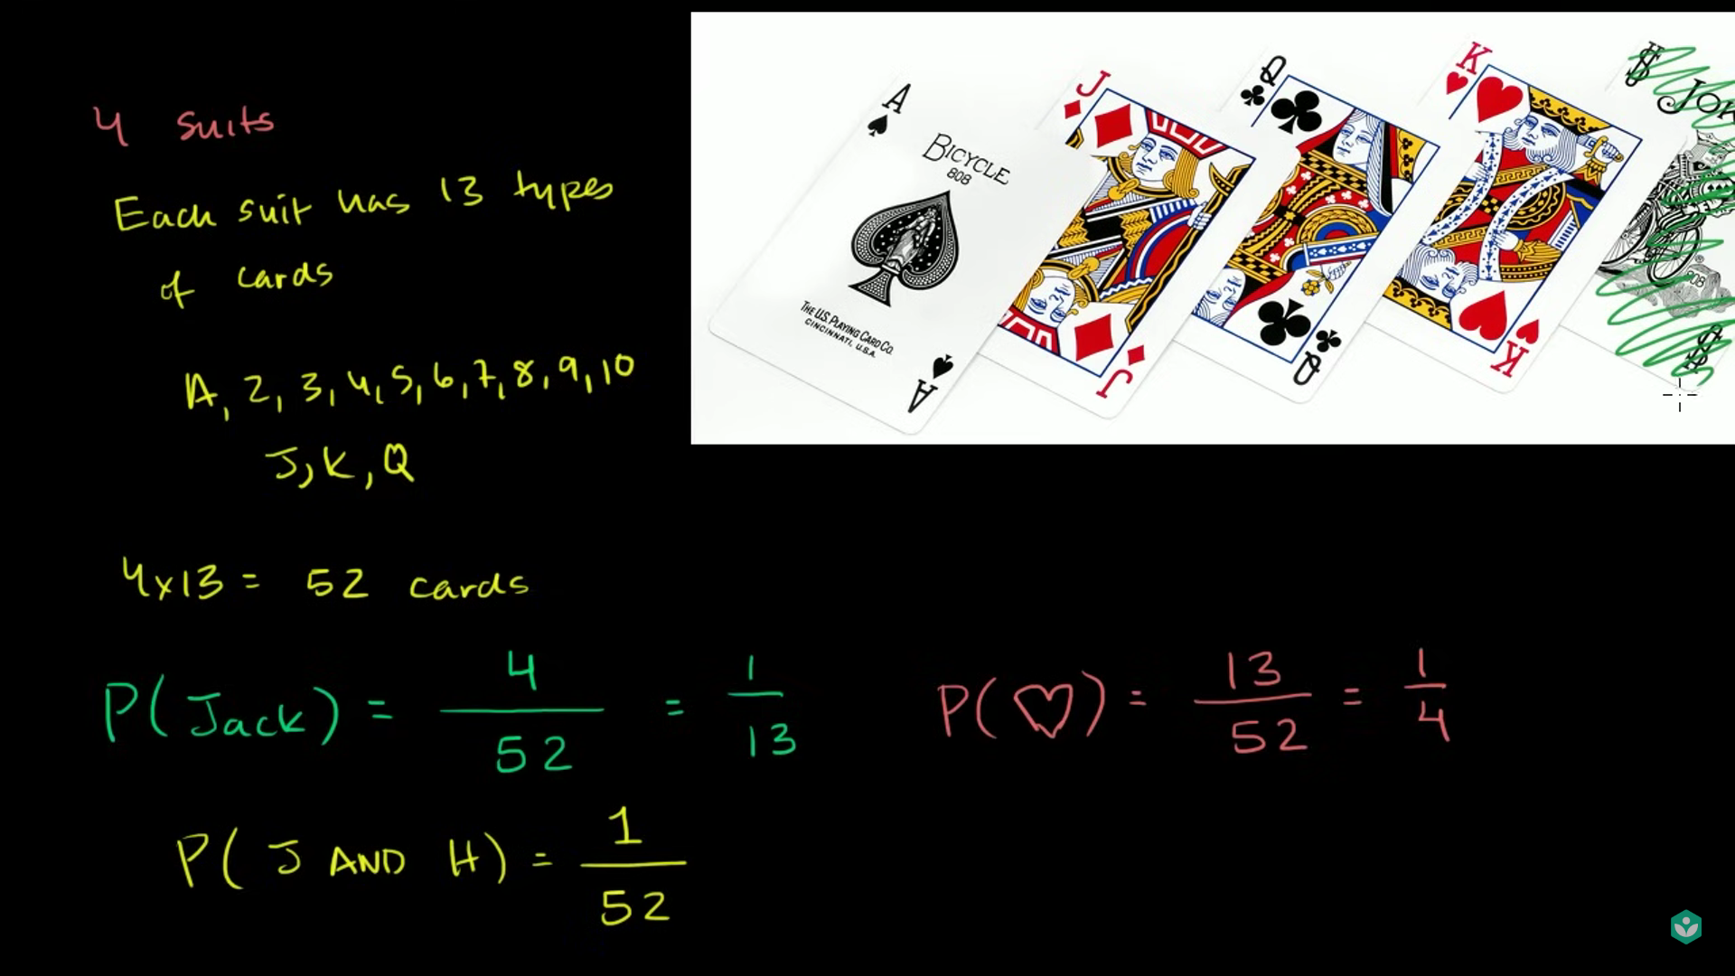

4 suits or sets means of 13 cards = 4 \* 13 = 52

Probability of getting jack

P(Jack) = 4 / 52 = 1 / 13

Probability of getting jack and heart

Means the cards meet two condition it is jack or comes under heart

P(J and H) = 1 / 52

Probability of Jack or heart

First count no of jack = 4

No of heart = 13

In vendiagram it show if we count both the common count twice means the card which meet both criteria count twice

$$P\left(J or H\right)=\frac{4+13-1}{52}=\frac{16}{52}=\frac{4}{13}$$

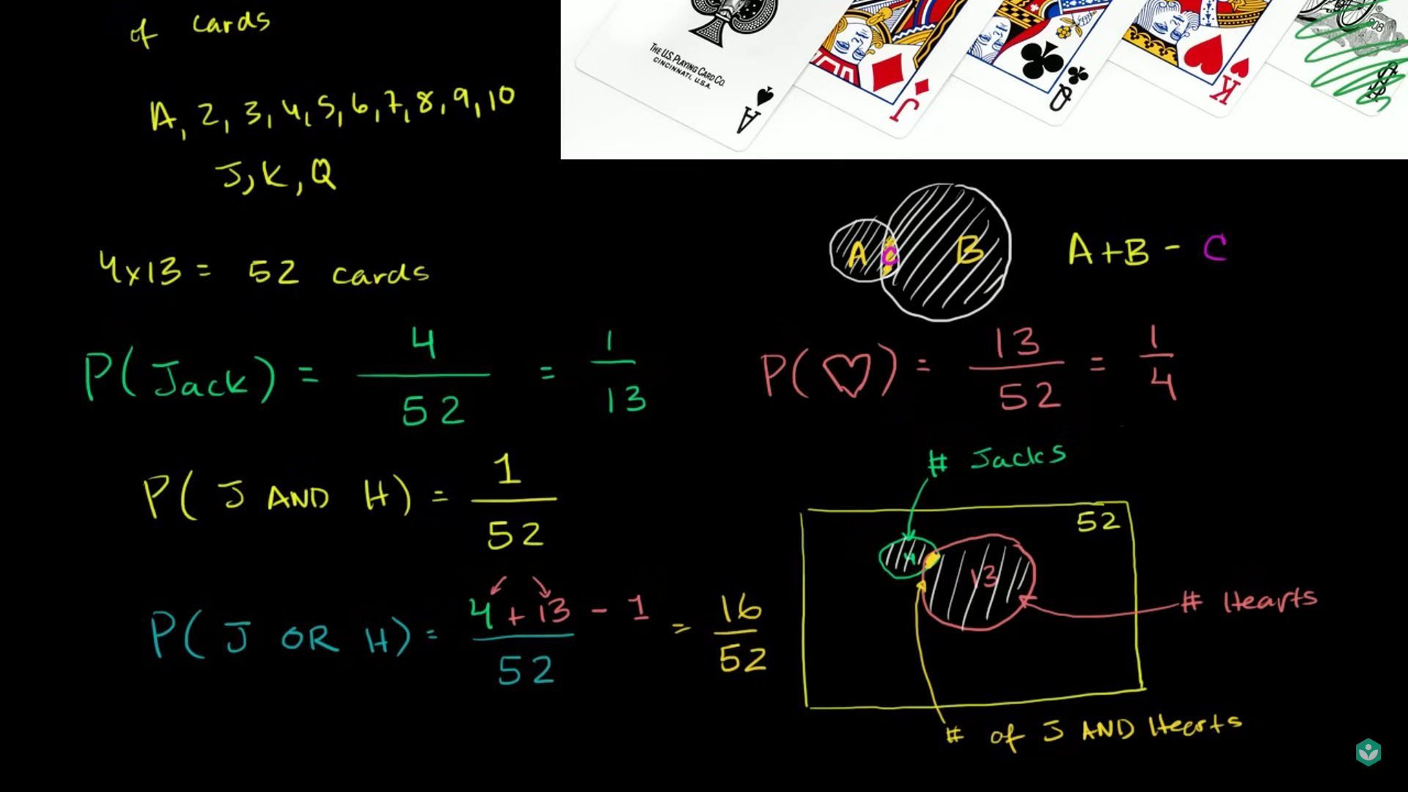

Lecture 3: Addition Rule for probability

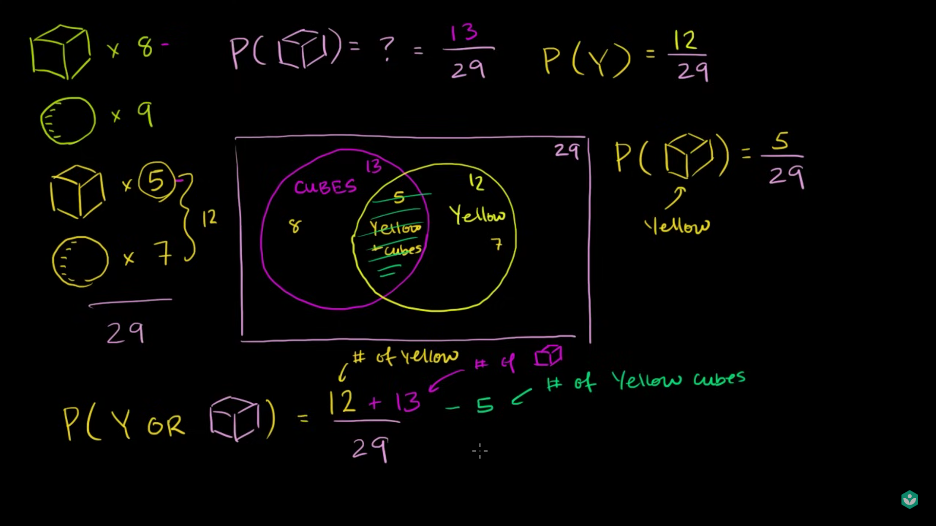

Lets consider we have 8 green cube and 9 green sphere , 5 yellow cube and 7 yellow sphere

Probability of yellow = $P\left(Y\right)=\frac{12}{29}$

Probability of Cube = $P\left(Cube\right)=\frac{13}{29}$

Probability of Yellow Cube = $P\left(Yc\right)=\frac{5}{29}$

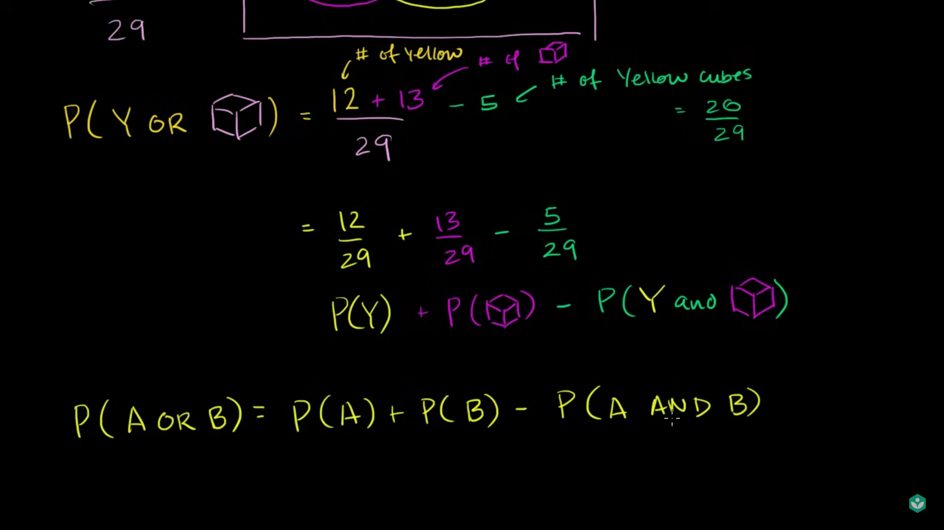

Lets calculate probability of (Yellow object or cube)

$$P\left(Y or Cube\right)=\frac{12+13-5 }{29}$$

Addition Rule of probability

$$P\left(A OR B\right)=P\left(A\right)+P\left(B\right)-P(A AND B)$$

A and B are present in both

If any element are not common we say mutually exclusive or else we say mutually inclusive

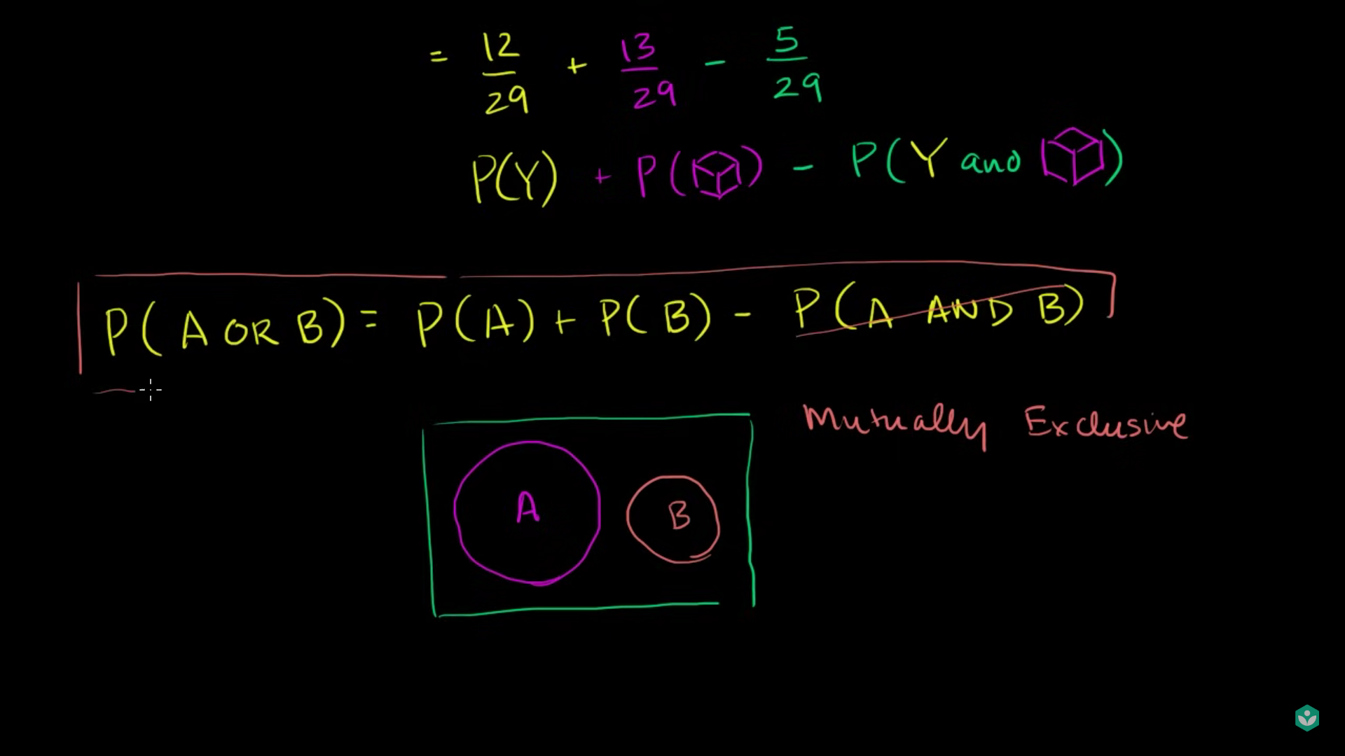

Exercise

Question One

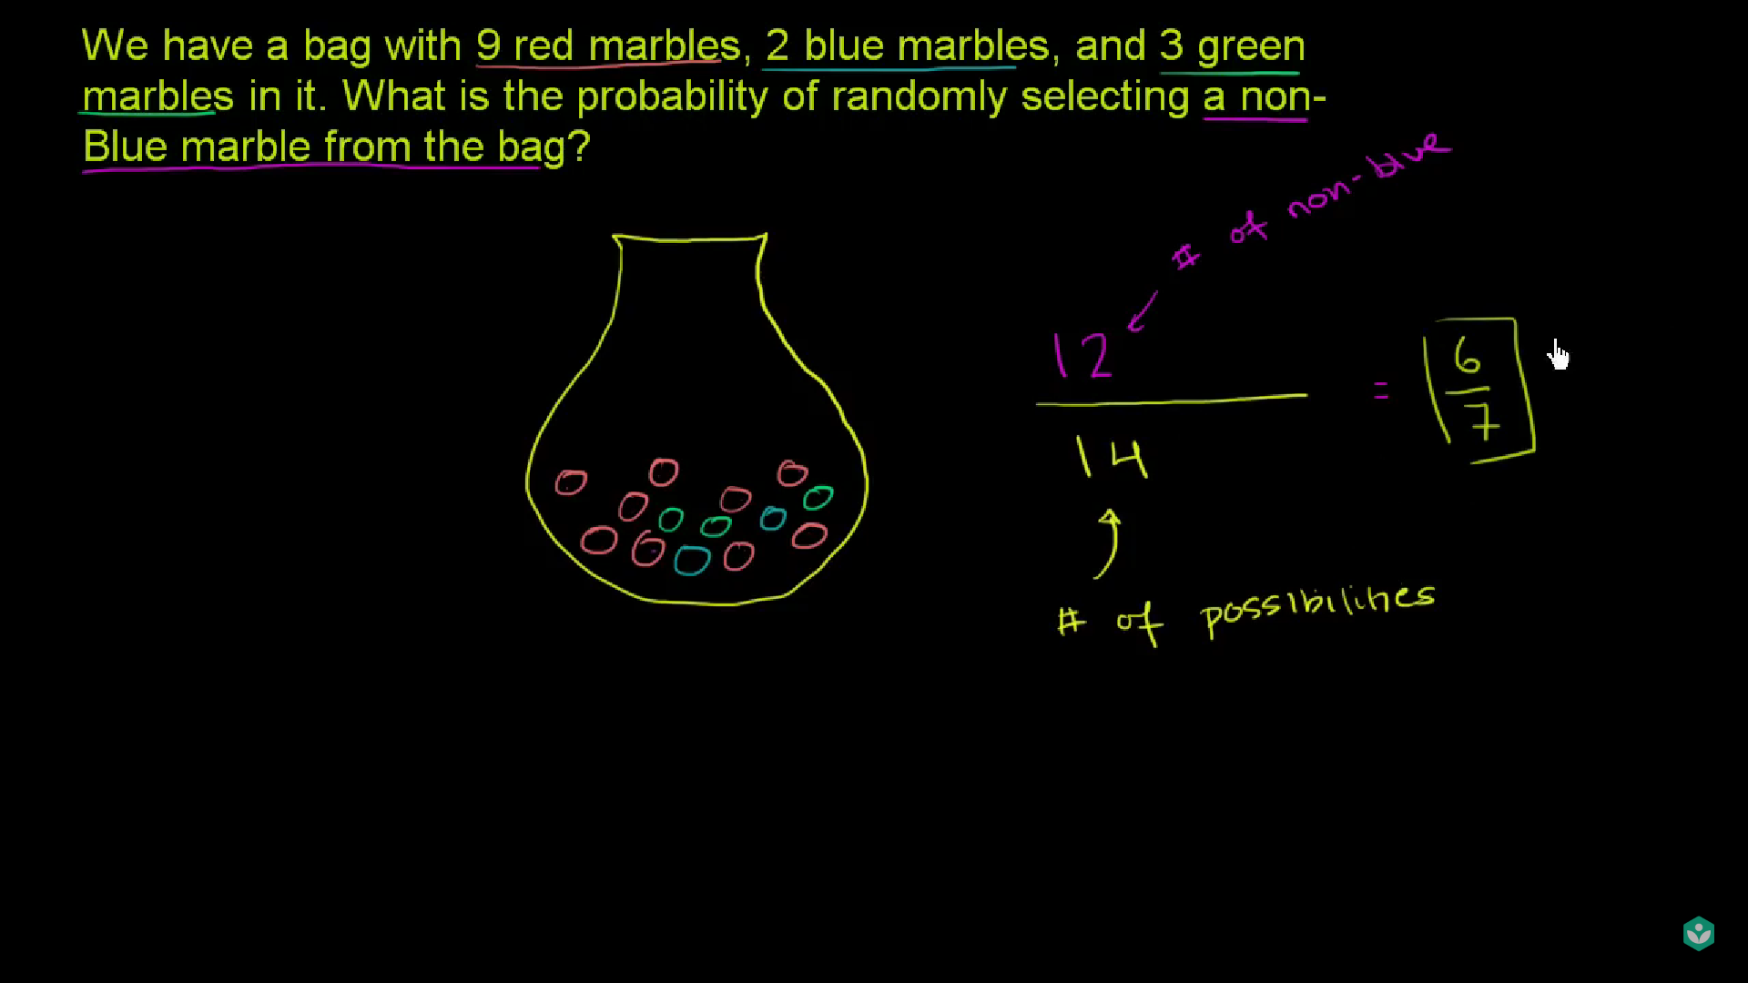

Question Two

If a number randomly choose from list what is the probability of that the number is a multiple of 5

[32,49,55,30,56,28,50,40,40,45,3,25]

$$P\left(5\right)=\frac{7}{12}$$

Question Three:

The circumference of circle is $36π$ contain in that circle is a smaller circle with area $16π$. A point is selected at random from inside the larger circle. What is the probability that the point also lies the smaller circle.

Radius calculation for larger circle

$$circumference :36π$$

$$C=2πr$$

$$\frac{36π}{2π}=\frac{2πr}{2π}$$

$$18π=r$$

For larger circle we get $r=18π$

For smaller circle

$$\frac{16π}{2π}=\frac{2πr}{2π}$$

Smaller circle = $18π$

Now Area of larger circle is

$$Area =πr^{2}$$

$$Area=π{\left(18\right)}^{2}$$

Area = 324 $π$

For smaller circle

$$P=\frac{16π}{324π}=\frac{4}{81}$$

Lecture 4: Compound Probability of Independent Events

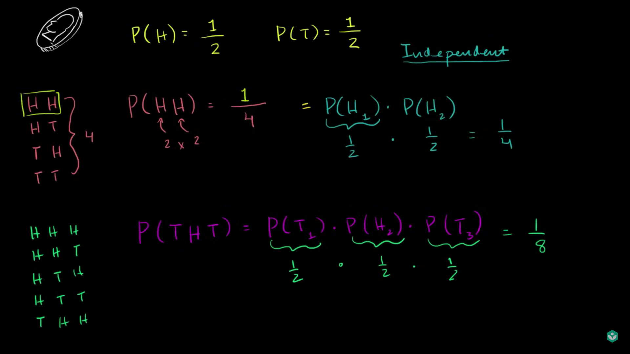

If a completely fair coin is toss the probability of head is $\frac{1}{2}$ and probability of tail is also $\frac{1}{2}$

So if two coins are tossed

N = {HH, HT, TH, TT}

What is the probability of getting HH

P(HH) = $\frac{1}{4}$ both head are completely independent event the first coin outcome does not affect the second one.

P(HH) = $P\left(H1\right)→\frac{1}{2} P\left(H2\right)→\frac{1}{2}=\frac{1}{2}*\frac{1}{2}=\frac{1}{4}$

What is the probability of P(HTH)

Lets say this are completely independents events are there so,

$$P\left(HTH\right)=P\left(H\right)*P\left(T\right)*P\left(H\right)=\frac{1}{2}*\frac{1}{2}*\frac{1}{2}=\frac{1}{8}$$

N = {HHH, HHT, HTH, THH,HTT, TTH, THT, TTT}

It is 1 of 8 equally likely possibility

Exercise 2: Coin Flipping Probability

Fair coin flip three time

N = {HHH, HHT, HTH, THH, HTT, TTH, THT, TTT}

Question 1:

Probability of at least one head

P(at least one head for three toss) = $\frac{7}{8}$

What happened if it say 20 toss it would be difficult but it is equiveelnt of probability of not getting not all tails

P(not all tails ) or p (all tails ) = 1 # it is mutually exclusive event not occur at same time

P(Not getting all tails in 3 flips) = 1 – P(TTT) = $P\left(TTT\right)=\frac{1}{2}+\frac{1}{2}+\frac{1}{2}=1-\frac{1}{8}=\frac{8-1}{8}=\frac{7}{8}$

Question 2:

Probability of at least one head in 10 flip

P( not getting tails in 10 flips)

1 – P(10 tails in row)

$$1-\frac{1}{2}*\frac{1}{2}*\frac{1}{2}*\frac{1}{2}*\frac{1}{2}*\frac{1}{2}*\frac{1}{2}*\frac{1}{2}*\frac{1}{2}*\frac{1}{2}=1-\frac{1}{1024}=\frac{1024}{1024}-\frac{1}{1024}=\frac{1023}{1024}$$

99.9% chance at least one head

Lecture 5: Probability without equally likely events

P(A) = $\frac{\text{\# of events satisfy A}}{\# \text{of}\text{ equally likely events }}$# this all about unbiased or fair coin

Now if we toss unfair coin there is a probability of getting head is 60% chance or tails is 40%

What is the probability of getting head, tails are calculated

